Choosing Between Low Flow and Regular Shower Heads: What to Know

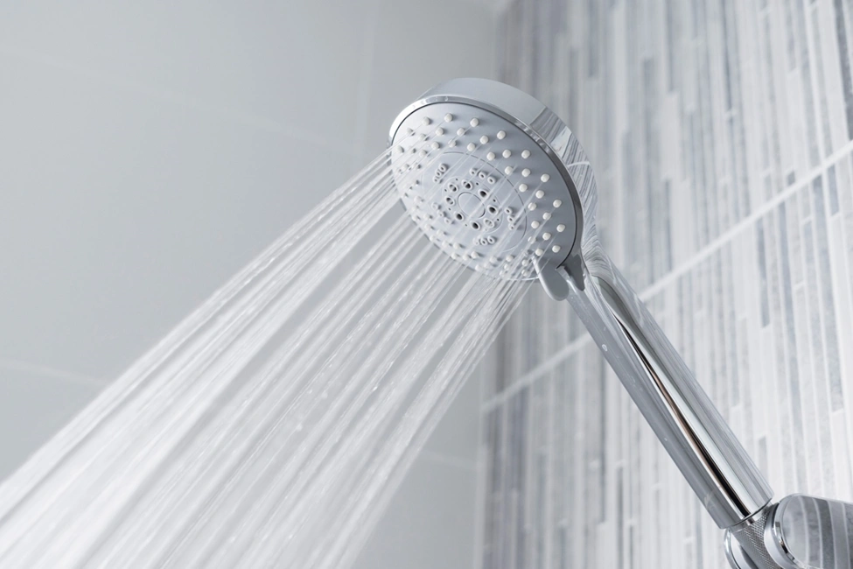
When it comes to upgrading your bathroom or simply improving your daily shower experience, one key decision you’ll face is choosing between a low flow shower head vs a regular shower head. This decision isn’t just about water pressure—it’s about water conservation, energy bills, comfort, and environmental impact. Understanding the differences and knowing what to prioritize can help you make a well-informed choice.

Understanding Shower Head Types

What Is a Low Flow Shower Head?
A low flow shower head is designed to reduce the amount of water used per minute during a shower without drastically compromising your experience. Typically, low flow shower heads use 2.0 gallons per minute (GPM) or less. Many modern models feature advanced aeration or pressure-compensating technologies that maintain a steady stream despite lower water usage.

What Is a Regular Shower Head?
A regular shower head usually delivers water at a higher flow rate, generally around 2.5 GPM or more. Older models installed before federal water regulations may even use as much as 5 GPM. These heads are known for strong water pressure and a more traditional showering experience, often preferred for their robust flow and rinsing capabilities.

Key Factors to Consider

Water Consumption
In the debate of low flow shower head vs a regular shower head, water consumption is a major consideration. A low flow shower head can save thousands of gallons of water per year. If you live in an area where water is scarce or expensive, this can lead to substantial savings on your utility bills. On the other hand, regular shower heads can waste water if not used efficiently.

Energy Efficiency
Less water usage also means less energy required to heat that water. Households that switch to low flow shower heads often notice a decrease in their energy bills. With regular shower heads, the hot water heater works harder, consuming more electricity or gas over time.

Shower Experience
Many users are concerned about the quality of their shower when switching. Regular shower heads often provide a fuller, more satisfying water stream. However, modern low flow models have come a long way. Technologies like pressure compensating valves, air infusion, and pulse sprays can simulate the feel of high water pressure while maintaining efficiency.

Environmental Impact
Choosing a low flow shower head is a small but significant step toward environmental sustainability. Reducing water and energy usage lessens the strain on municipal systems and helps combat climate change. In contrast, using a regular shower head contributes to higher water and energy consumption, which adds to your carbon footprint.

Costs and Long-Term Savings

Initial Cost
Low flow and regular shower heads can range widely in price, from $10 to over $100 depending on features and brand. While low flow options may seem more expensive initially, they pay off in the long run through reduced water and energy bills.

Maintenance and Lifespan
Both types typically require minimal maintenance, but low flow shower heads may need occasional cleaning to prevent mineral buildup that can affect performance. Quality regular shower heads can also last a long time but tend to use more water, increasing the frequency of maintenance for related plumbing and water heating systems.

Rebates and Incentives
Many local governments and utility companies offer rebates or discounts for purchasing and installing water-efficient fixtures. When weighing low flow shower head vs a regular shower head, it’s worth checking if financial incentives are available in your area. These can make a low flow option even more cost-effective.

Performance in Different Situations

Low Water Pressure Homes
If your home already suffers from low water pressure, choosing the right shower head becomes crucial. Regular shower heads may exacerbate the problem, resulting in a weak stream. Some low flow models are specifically designed for low-pressure environments and can optimize performance better than traditional ones.

Large Households
For households with multiple family members taking showers every day, water efficiency becomes increasingly important. Using low flow shower heads can significantly cut down on water usage without sacrificing too much on comfort, especially with modern designs that enhance spray force.

Personal Preferences
In some cases, personal comfort trumps all other factors. If a powerful spray and fast rinsing are top priorities for you, a regular shower head might still be the better fit. However, it’s a good idea to test a high-quality low flow model first—many users are surprised by how effective and satisfying they can be.

Technology and Innovations

Aerating Low Flow Heads
These mix air with water, creating a mist-like spray that feels luxurious while using less water. The experience may feel lighter but still effective.

Laminar Flow Heads
These deliver individual streams of water, maintaining pressure and minimizing heat loss. Laminar flow designs are especially useful in climates where hot water quickly cools.

Smart Shower Heads
Some modern shower heads, whether low flow or regular, come with features like timers, temperature control, and app connectivity. These smart additions can further enhance efficiency and comfort.

Installation and Compatibility

Ease of Installation
Both types are generally easy to install without professional help. Most shower heads screw onto a standard shower arm, making them a straightforward DIY upgrade.

Compatibility with Water Heaters
Low flow models may extend the capacity of your hot water system since they use less water per minute. This is especially beneficial in homes with small water heaters or high shower demand.

Final Thoughts: Making the Right Choice
When evaluating low flow shower head vs a regular shower head, there is no universal answer—it depends on your priorities, lifestyle, and values. If conserving water and reducing energy bills are important to you, a low flow shower head is likely the better choice. For those who prioritize strong water pressure and don’t mind higher utility costs, a regular shower head might still appeal.
Fortunately, innovations in low flow technology are closing the gap between efficiency and performance. Many users who make the switch find that they don’t miss the higher flow rate once they adjust. Ultimately, the best choice balances comfort, savings, and sustainability.

